A **majority circuit** is a combinational circuit whose output is equal to 1 if the input variables have more 1’s than 0’s. The output is 0 otherwise. Design a 3-input majority circuit by finding the circuit’s truth table, Boolean equation, and a logic diagram.

SOP:

“Caden is correct” - Isaac Killbourne

Nick Boisclair:

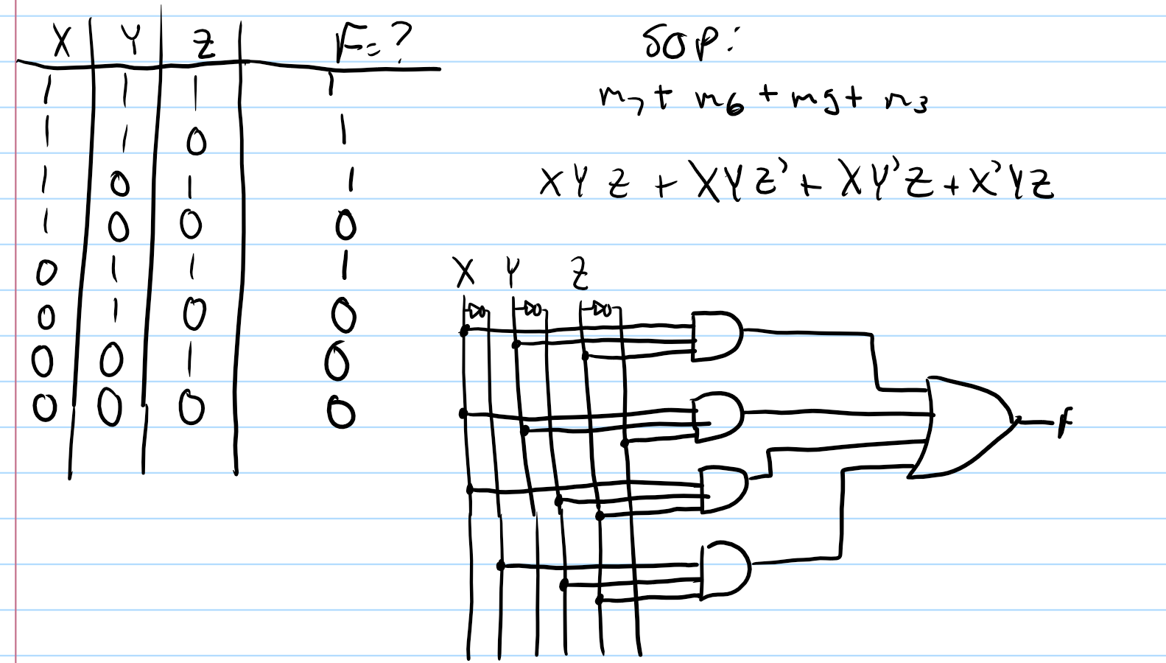

POS:

**Phillip Bocse**

